Access advising information on the Globe

- Go to the “My Academic Information” page on the students tab of the Globe.
- Scroll all the way to the middle/right side of the page to the “Course Needs” Portal
- Click on “click here to view the Course Needs for...

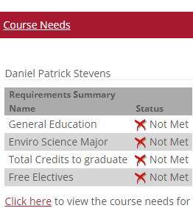

Course Needs (below) will help you map your progress towards graduation. It is the same information as
The Degree Audit screen, but in a more user friendly format. Before doing anything else, click on
Re-calculate student progress!!! Then, click on any of the requirements.

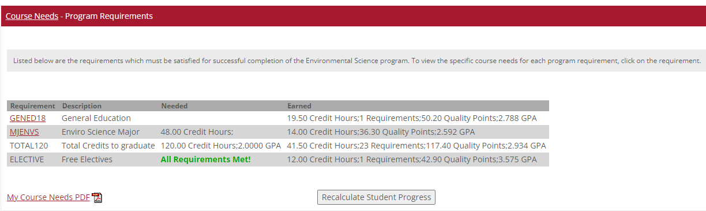
First

This next page will tell you a few things. For example, with this student, you will see that the status is
In progress for Mind-Body Wellness and Skills for Lifelong Learning, and they still show required for the rest of the General Education requirements. The “My Course Needs PDF” will provide an overview of all requirements applied to the student (General education, major, minor, course maximums, etc.).

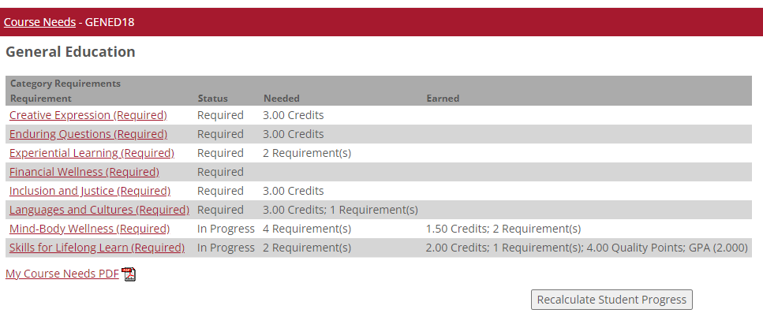

The “My Course Needs PDF” (below) gives you a color coded breakdown of requirements as well as the
Grade and credits earned in each course. : 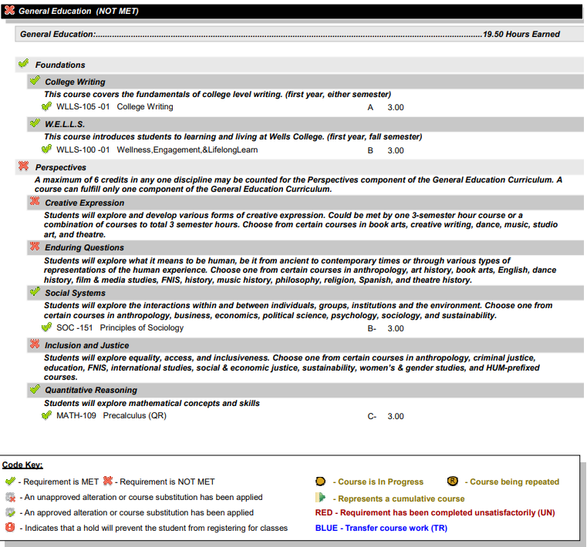

The Free electives category is a place to look for courses that aren’t being applied anywhere else. If there is a course in the free elective category that should be in your major/minor/general education, please let us know!

Want to explore a new major?? Minor? You can do so by using this portlet. Be sure to choose the major with your catalog of entry year next to it. Tip: if you entered in January of 2022, your catalog year is 2021-2022.
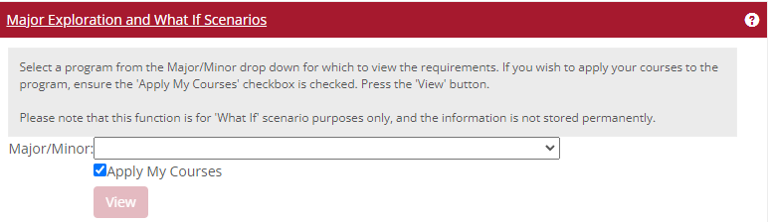

Want to calculate your projected GPA?? Use the portal below.
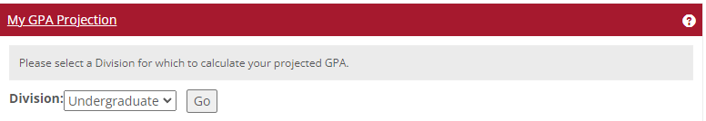

QUESTIONS?? PROBLEMS?? Email Registrar at registrar@wells.edu or visit the office at Macmillan 202.

